CS5551 Advanced Software Engineering Lab Assignment #4

***Android App that uses Flickr image search API and has login page which redirects to web service page.***

***Technology used:*** Java, XML, Android Studio IDE,

**Screenshots:**

1. Home screen of virtual mobile screen

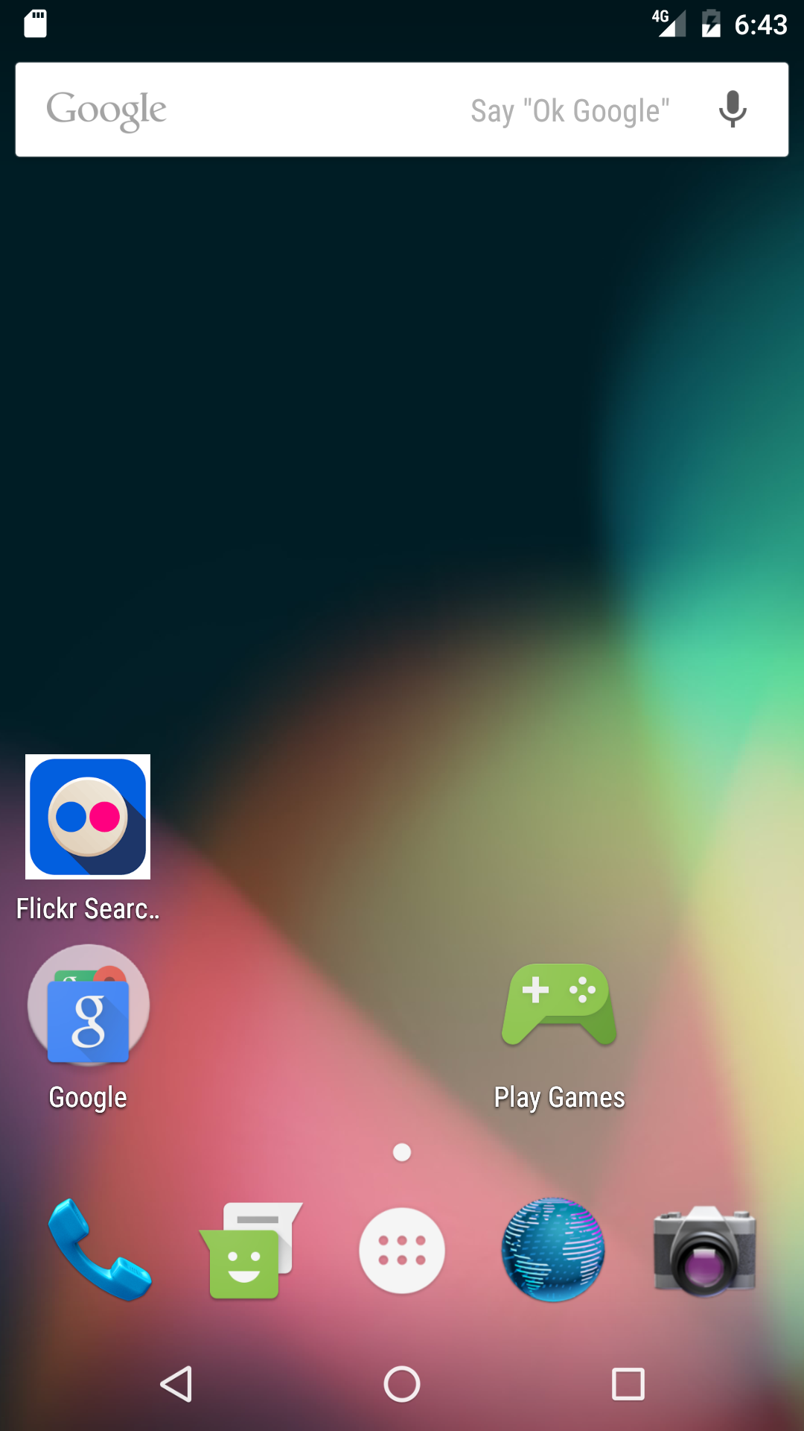

Here Flickr search is the app to be implemented, once we open the app we get below screen

Input credentials username: Admin123, password :Lab004

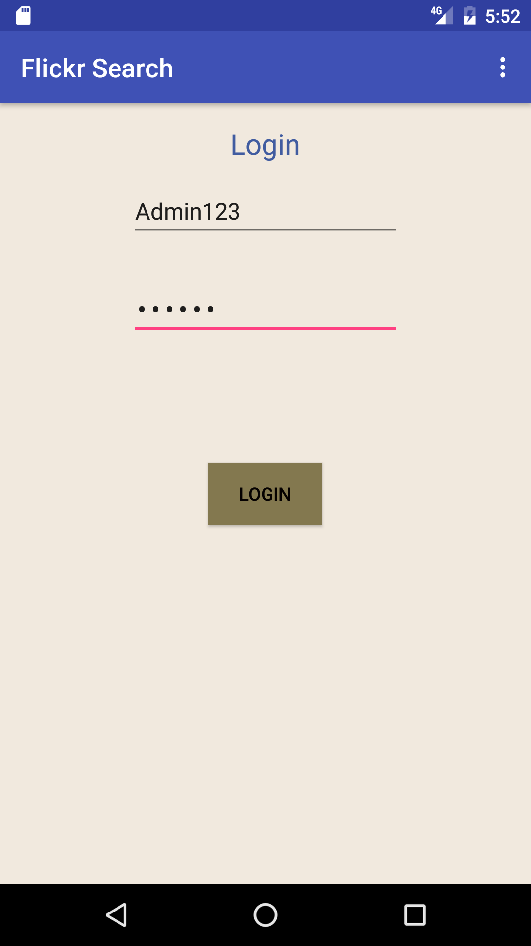

Once we login into the app, it redirects to image search page

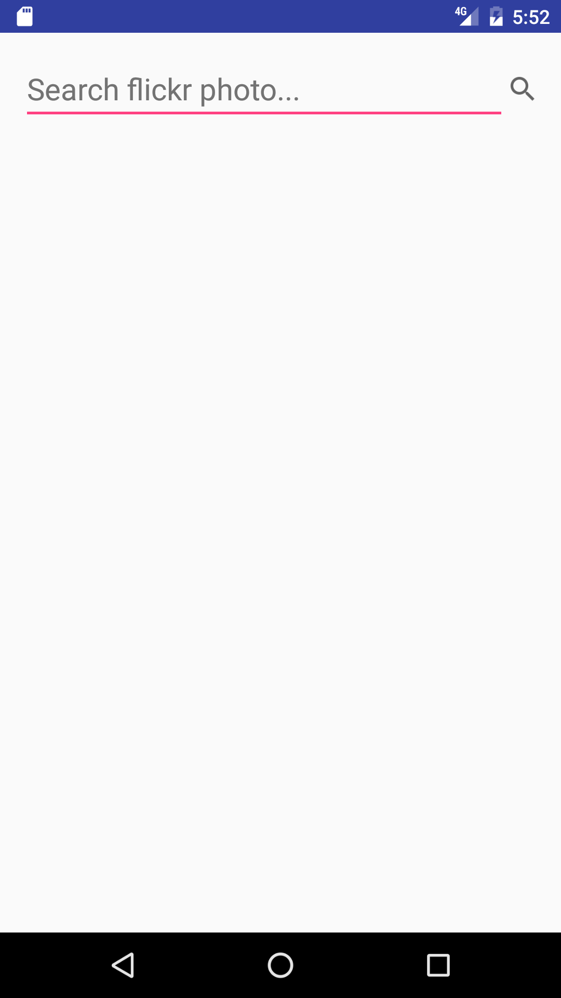

In the search bar we give input for image serach, for example here I search for images of famous Indian cricketer Virat Kohli.

Search results are shown retrieved as show below

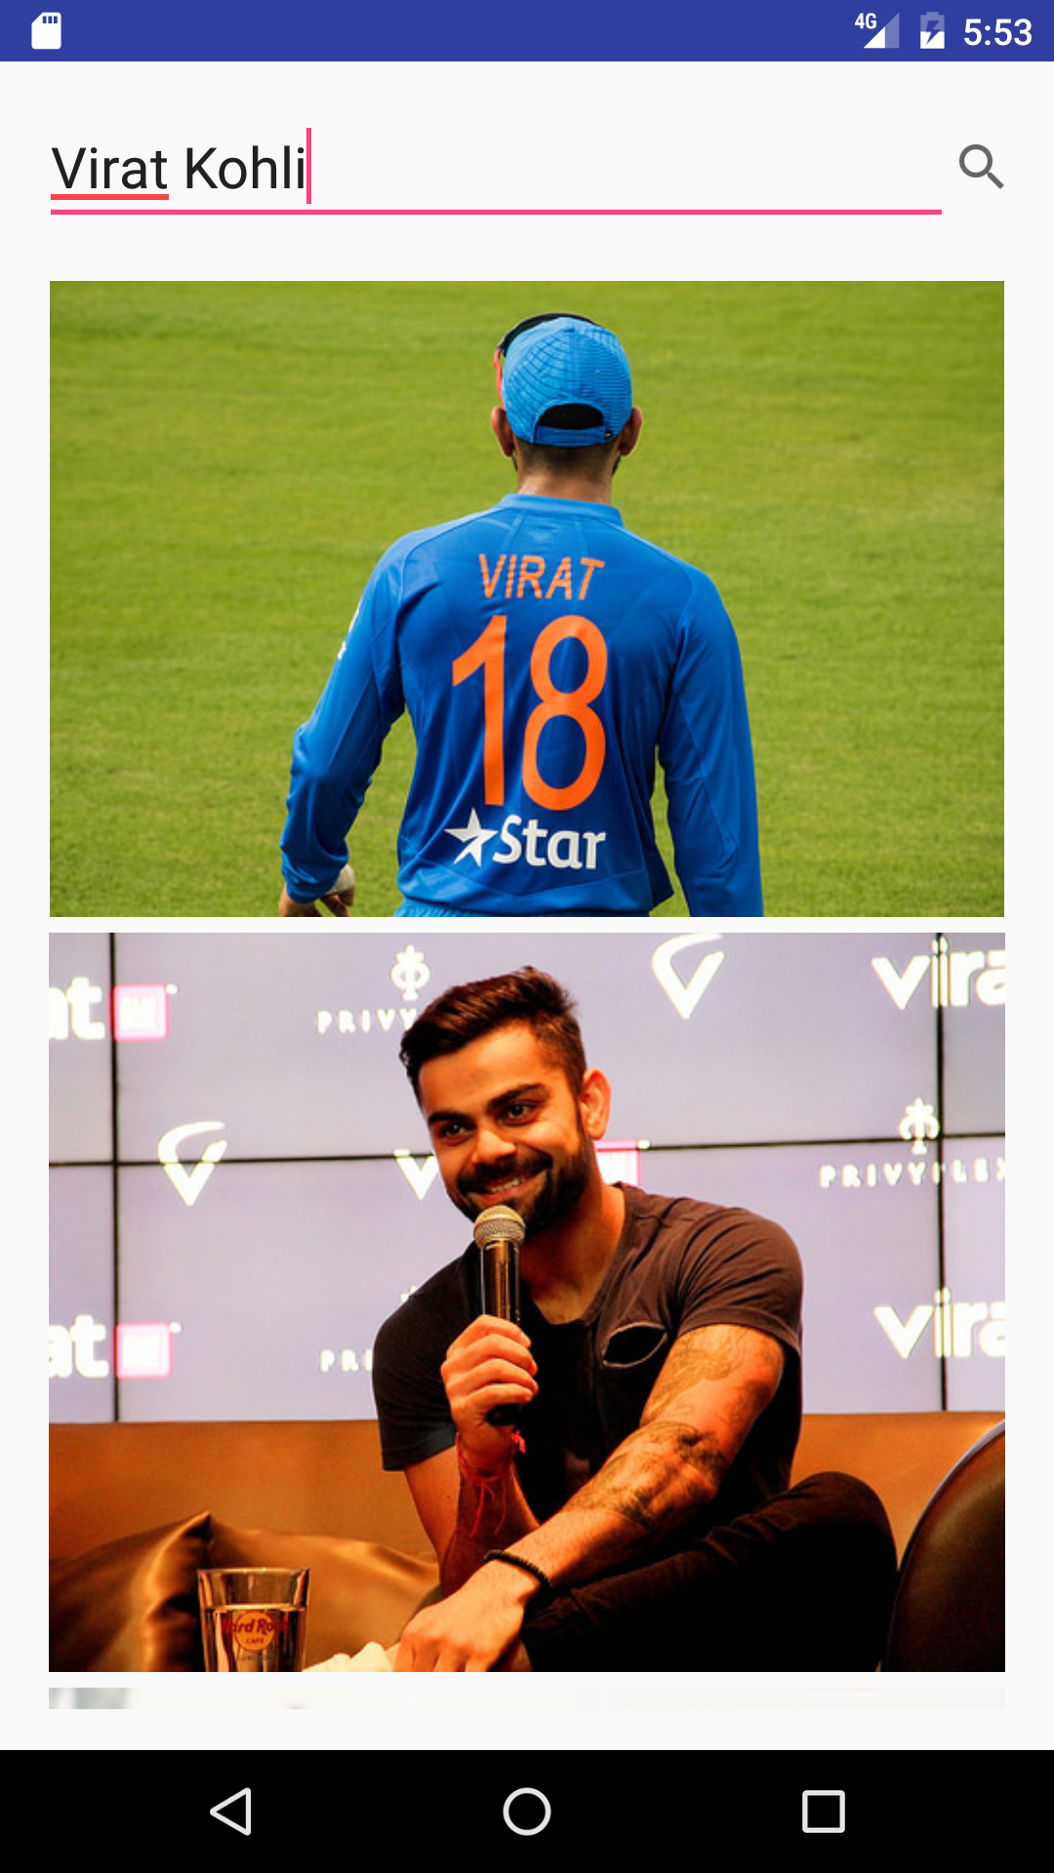

Once we click on any image it redirects to image description page as shown below

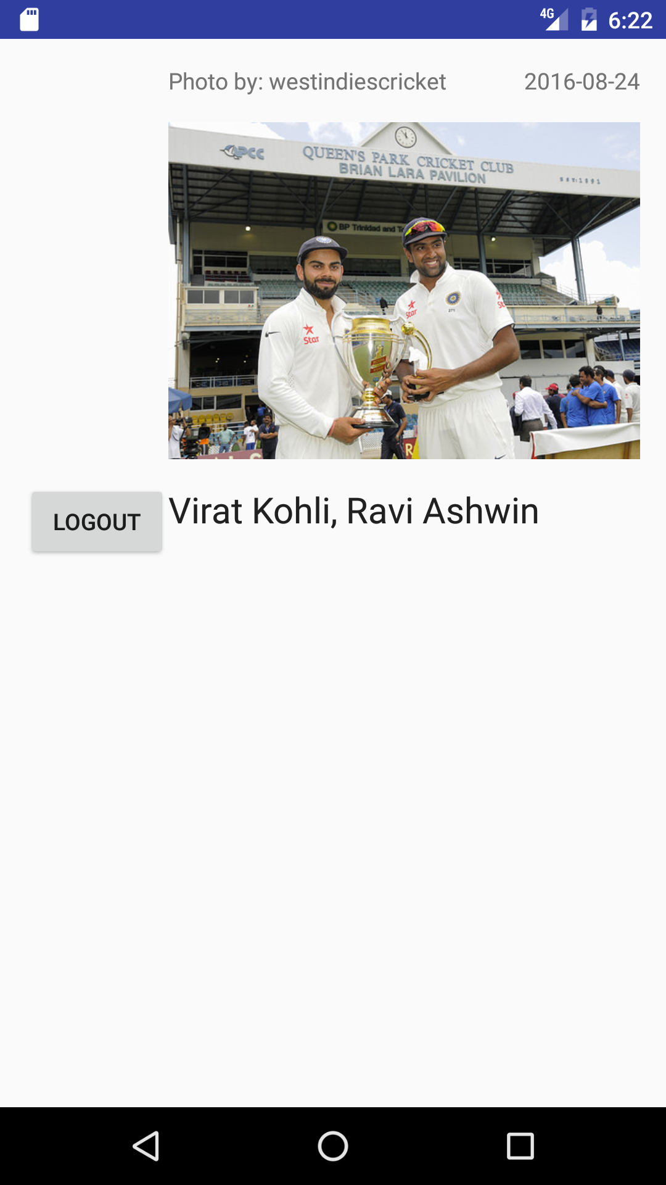

**Login Validation**

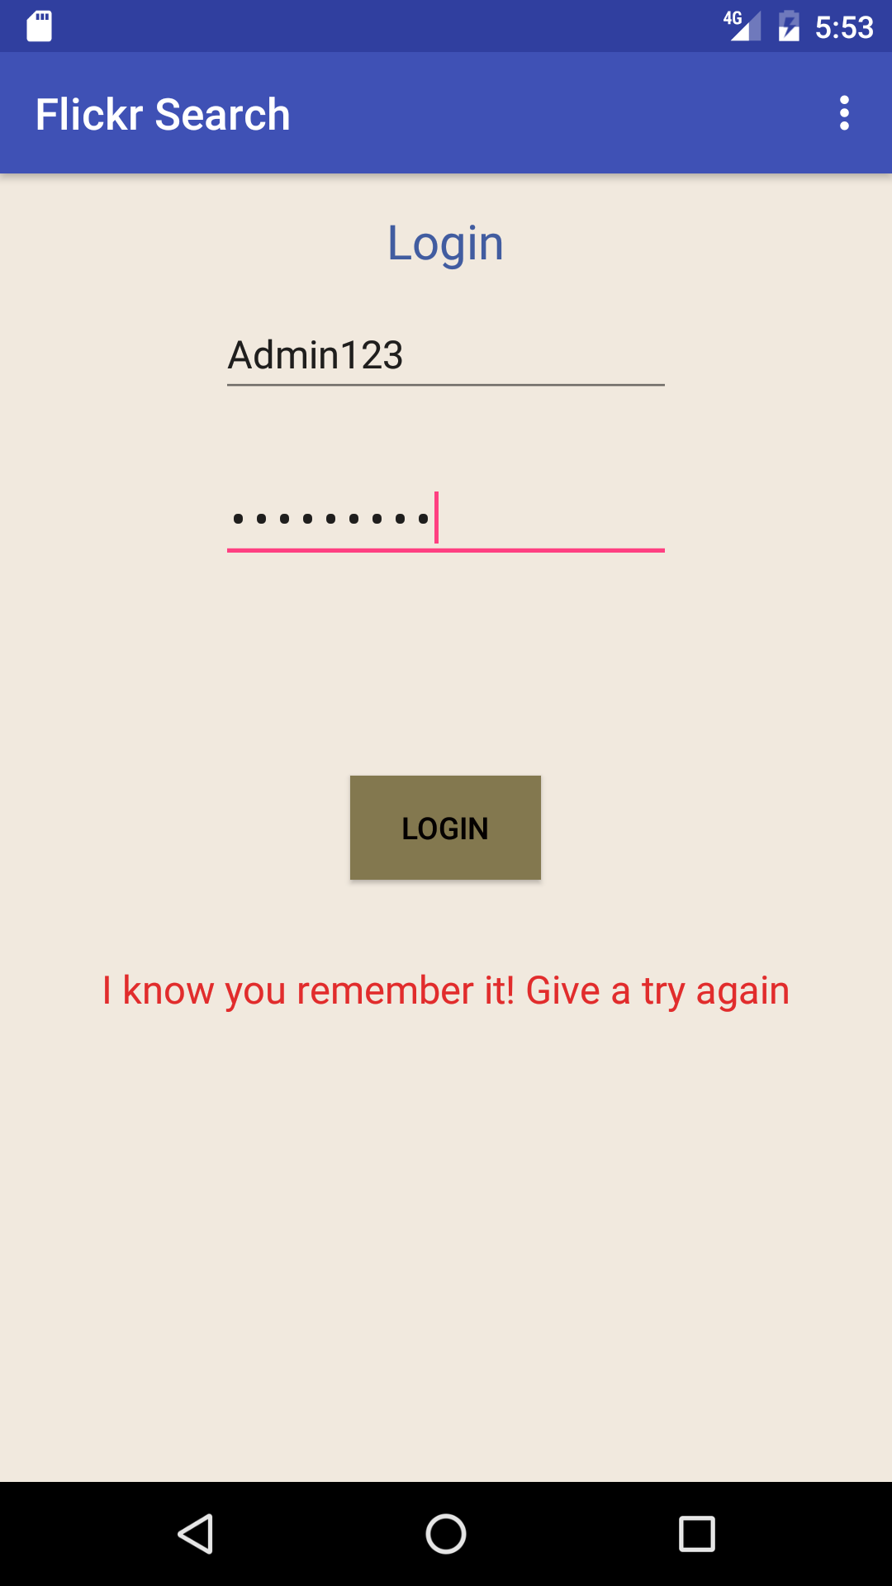If login credentials are incorrect it gives a prompt to enter correct credentials

**References:**

* <http://www.flickr.com/services/api/flickr.photos.search.html>
* <http://stackoverflow.com>
* <https://developer.android.com/>
* Class Tutorial